

***Hands-on Exercise 7.1 [15-points]: The Decorator Pattern (:20 min):***

|  |  |
| --- | --- |
| Name: |  |
| Instructions: | * According to several studies, the industry values documentation and excellent written and oral communication skills. The purpose of this part of the class is to encourage you to gain these skills. * Rename this document, fill-out this form, and submit it to the same link where you retrieved this material. * Backup your work; you may need this in the future or as part of an exam. * Organizations value attention to detail. As part of cultivating a culture of producing quality products and due diligence, please review your work at least twice before rendering them to your professor. Remember that resubmissions are not allowed. Thank you for your willingness to improve and to embrace an engineer's mindset. |

1.❑ Let’s practice: Implement the code below and get the code to run.

***The Project***

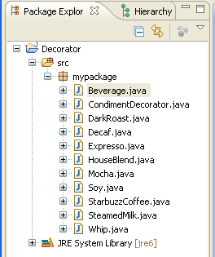

***The Code***

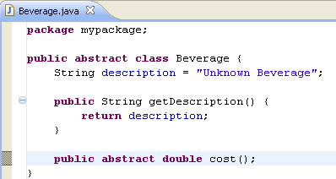

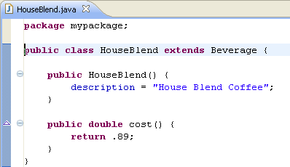

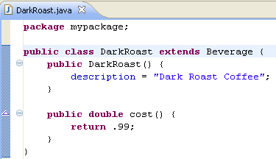

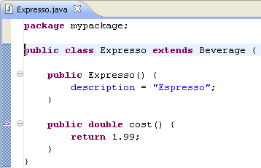

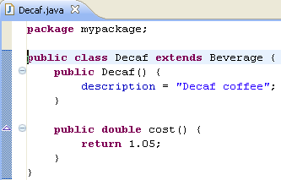

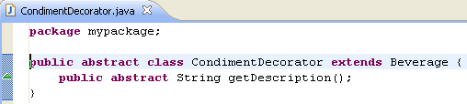

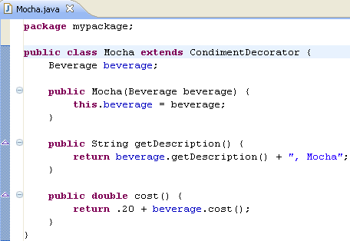

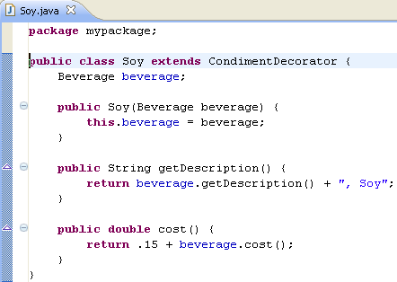

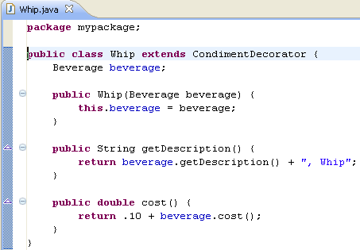

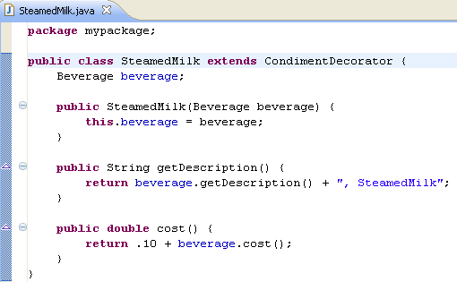

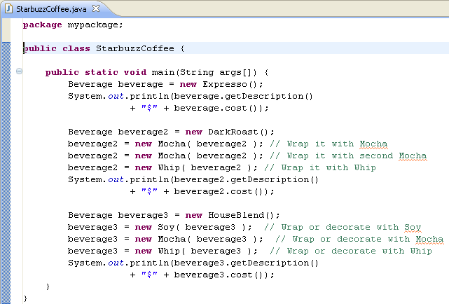

***The Output:***

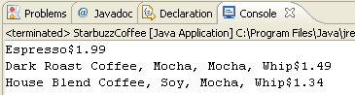

***Notes: below is an example code how to format currency in Java.***

***Source:*** [*http://www.java2s.com/Code/Java/Development-Class/Formatanumbertocurrency.htm*](http://www.java2s.com/Code/Java/Development-Class/Formatanumbertocurrency.htm)

# import java.text.NumberFormat; public class Mortgage {   public static void main(String[] args) {     double payment = Math.random() * 1000;     System.out.println("Your payment is ");     NumberFormat nf = NumberFormat.getCurrencyInstance();     System.out.println(nf.format(payment));   } }

2.❑ Paste your code and output below.

|  |
| --- |
|  |

3.❑ Modify exercise 7.1 based on the following changes:

Starbuzz have introduced sizes to their menu. You can now order a coffee in tall, grande, and venti sizes (translation: small, medium, and large). Starbuzz saw this as an intrinsic part of the coffee class, so they’ve added two methods to the Beverage class: setSize() and getSize(). They’d also like for the condiments to be charged according to size, so for instance, Soy cost 10¢, 15¢, and 20¢ respectively for tall, grande, and venti coffees (new values next page.)

|  |  |  |  |
| --- | --- | --- | --- |
| **Starbuzz Coffee** | | | |
| **Condiments** | **Small** | **Medium** | **Large** |
| Steamed Milk | **5**¢ | **10**¢ | **15**¢ |
| Mocha | **15**¢ | **20**¢ | **25**¢ |
| Soy | **10**¢ | **15**¢ | **20**¢ |
| Whip | **5**¢ | **10**¢ | **15**¢ |

4.❑ Paste your code below.

|  |
| --- |
|  |

Paste your screen shot output here [Ctrl] + [PrtScn]. Make sure your output image is readable, **magnify** if necessary so the instructor can efficiently assess work. A sample magnified output is shown below; replace this image with your own. Use Snipping Tool and Window’s Paint program to cut and paste your visuals into here.

|  |
| --- |
|  |

5.❑ Draw the equivalent UML class diagram of your solution?

|  |
| --- |
|  |

6.❑ Write your topmost question regarding this topic or exercise. (This question is optional, but you must participate in the Critical Thinking section that follows.)

7.❑ **Critical Thinking:** Take the time to pause and think. If you are asked to make a test question (for the midterm or final exam) based on this topic, what would be the question, and what is your corresponding answer? Be creative in your response to this crucial question.

|  |
| --- |
|  |

[](http://images.google.com/imgres?imgurl=www.skyscript.co.uk/im/trophy.jpg&imgrefurl=http://www.skyscript.co.uk/im/&h=214&w=180&sz=6&tbnid=ECCiP8U-7NsJ:&tbnh=99&tbnw=84&prev=/images?q=trophy&svnum=10&hl=en&lr=&ie=UTF-8&oe=UTF-8&sa=G)Congratulations! You’ve just learned Decorator Pattern.

|  |  |  |  |  |
| --- | --- | --- | --- | --- |
| GRADING RUBRIC | | | | |
| Grading Criteria | 3  **Exceeds**  *Excellent*  Epic Wow | 2  **Meets**  *Satisfactory*  O.K. | 1  **Partially Meets**  *Below Expectations*  Not Yet | 0  **Does Not Meet**  *Unacceptable*  Fail |
| **Coding** | +5- Code is excellent, comments are added, and different techniques were used. | +3-Code is O.K., and program works. | +2-Code works, but still needs improvement. | Unfortunately, no coding. |
| **Completeness** | +5-Completed all the required work and added more examples. | +3-Completed all the work required. | +2-Partially completed the work required. | Unfortunately, did not complete the work required. |
| **Output and diagram** | +5-Outputs are correct, and provided additional output cases. | +3-Output meets requirements and is readable. | +2-There is output, but not readable, and/or needs improvement. | Unfortunately, no output, or diagram was generated. |
| **Late** | Excellent, you submitted it before the deadline. | -5, unfortunately for submitting after the deadline. | -10, unfortunately for submitting several weeks after the deadline. | -15, unfortunately, for submitting very late. |